Current State Overview

Current State Overview 1
Organizational Structure 2
Key Systems and Tools 2
Existing Data Infrastructure 2
Interdepartmental dependencies 2

Organizational Structure

Overview
Metropolitan’s organizational structure is designed for strategic leadership, investment execution, and operational efficiency. The firm operates through four primary divisions:
- Senior Management – Provides overall governance, risk oversight, and firm-wide leadership.
- Investment Management – Responsible for deal sourcing, underwriting, and asset management.
- Business Management – Oversees finance, investor relations, legal, and operations.
- Investment Committee – Exercises final investment decision-making authority.
With 31 professionals as of December 2024, Metropolitan maintains a highly specialized and disciplined team, ensuring robust investment strategy execution.

Senior Management
The Senior Management team is responsible for corporate governance, compliance, and strategic oversight.

Key Executives
- Paul Lisiak – Managing Partner, Chief Investment Officer (CIO) | 26 years of experience | University of Pennsylvania
- Julian Weldon – General Counsel, Chief Compliance Officer (CCO) | 27+ years of experience | University of East Anglia
- Stephen Faughnan – Managing Director | 26+ years of experience | Pace University, NYU Stern

Primary Responsibilities
✔ Investment Strategy & Execution
✔ Legal & Compliance Oversight
✔ Firm-wide Governance & Risk Management
Senior Management provides firm-wide leadership while ensuring regulatory compliance and risk mitigation.

Investment Committee
The Investment Committee (IC) is responsible for final investment approvals, portfolio oversight, and risk assessment.

Committee Members
- Paul Lisiak – Managing Partner, CIO
- Adrian Blumfield – IC Member | 30+ years of experience | University of Cambridge, London Business School
- Fred Ganning – IC Member | 30+ years of experience | Seton Hall University

Core Functions
✔ Final Investment Decision-Making
✔ Risk & Portfolio Management
✔ Fund Strategy & Capital Allocation
The IC ensures disciplined investment selection, risk mitigation, and adherence to the firm’s strategic objectives.

Investment Management
The Investment Management team is responsible for deal origination, underwriting, and active asset management.

Investment Sourcing & Underwriting
Handles deal origination, due diligence, and underwriting.

Leadership
- George Alifragis – Head of Operating Expert Network
- Richard Lin – Managing Director

Team Structure
✔ Vice Presidents & Principals – Lead investment sourcing and execution.
✔ Associates & Analysts – Support financial modeling, due diligence, and execution.
✔ 500+ Operating Expert Network – Provides specialized industry insights.

Asset Management
Responsible for post-investment oversight, loan servicing, and portfolio monitoring.

Leadership
- Alex Verba – Managing Director

Team Composition
✔ Vice Presidents & Associates – Oversee borrower relationships, financial monitoring, and performance optimization.
Total Investment Management Team: 14 Professionals

Business Management
The Business Management division oversees finance, investor relations, operations, and legal compliance.

Finance & Accounting
Responsible for financial reporting, fund accounting, and audit coordination.
- Douglas Gold – Chief Accounting Officer & Senior Vice President
- Team: Vice Presidents, Controllers, Fund Accountants.

Investment Operations & Reporting
Manages data analytics, investment performance reporting, and internal controls.
- Jason Bircann – Vice President
- Team: Senior Operations Associates & Analysts.

Investor Relations
Handles LP communications, fundraising support, and investor reporting.
- Scarly Almonte – Senior Associate

Firm Operations
Ensures legal compliance, administrative efficiency, and corporate governance.
- Kevin O’Block & Megan Krishnamurthy – Vice Presidents, Office of the CIO
- Benjamin Bertan – Associate General Counsel
Total Business Management Team: 14 Professionals

Key Systems and Tools – TO BE ADDED

Existing Data Infrastructure – TO BE ADDED

Interdepartmental Dependencies
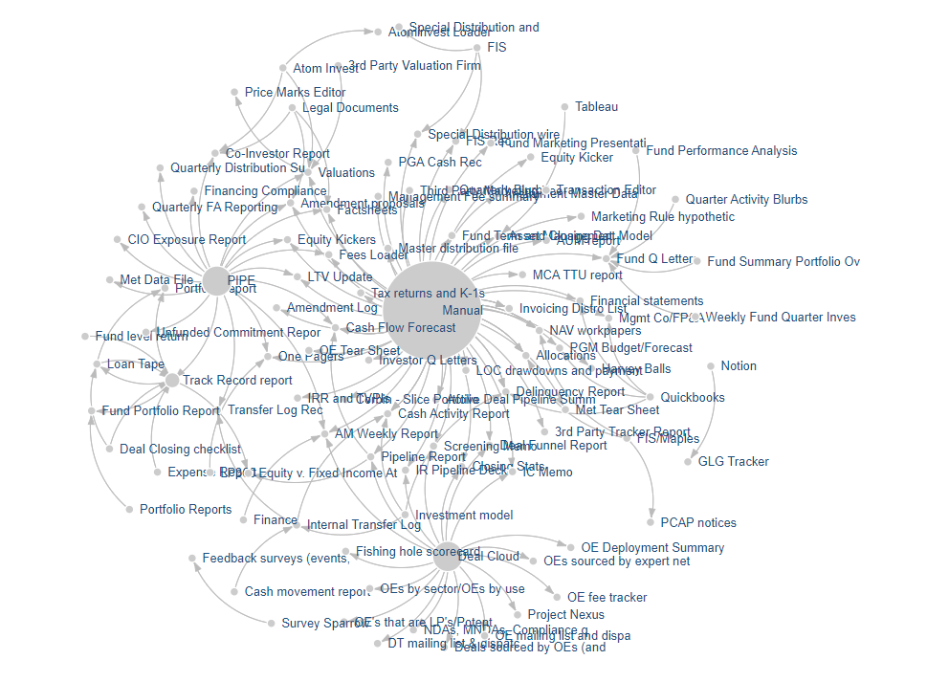
Network graph -Report/Deliverable with Data Sources and Data Source Owner

As visible in the network graphs, Metropolitan leverages multiple data sources to produce the majority of its deliverables. While this approach allows for the incorporation of diverse and detailed inputs, it inherently demands significant coordination and effort across various teams. This reliance on cross-functional collaboration introduces challenges, particularly when team availability is constrained, leading to inefficiencies, delays, and bottlenecks in the process. The time and resources required to synchronize efforts across departments highlight an opportunity to optimize workflows.
Compounding these challenges, several reports require insights and input from Asset Managers and Deal Team members, which are often not formally documented or stored in any centralized repository, making it difficult to access, track, and ensure consistency across deliverables. This lack of a standardized process for capturing critical information further complicates the already intricate workflow.
A significant portion of the data sources illustrated in the chart originates from manual inputs. This highlights a reliance on either data derived from other reports or contributions from other teams, over which the report owner has limited or no direct visibility. Such manual dependencies can lead to several challenges, including delays caused by misaligned timelines between teams, inaccuracies arising from errors in manual data transfer, and inefficiencies related to the lack of a streamlined, automated flow of information.
Moreover, this dependence on external inputs creates a lack of transparency, making it difficult for the report owner to fully understand the origins, quality, and context of the data they rely on. This scenario not only hinders the ability to identify and resolve data inconsistencies promptly but also increases the effort required to track and validate information. As the scale and complexity of these dependencies grow, they can further exacerbate operational inefficiencies and negatively impact the quality and timeliness of report delivery.
Addressing these issues would require an emphasis on automating data flows, integrating centralized data management solutions, and fostering cross-team communication to enhance visibility and coordination.
Specific examples:
Fund Quarterly Letter
In addition to the reliance on multiple teams, many key reports are heavily dependent on other internal deliverables, further increasing complexity. For example, fund quarterly letters require a combination of financial inputs from the FP&A, Fund Accounting, Asset Management and Investor Relations.
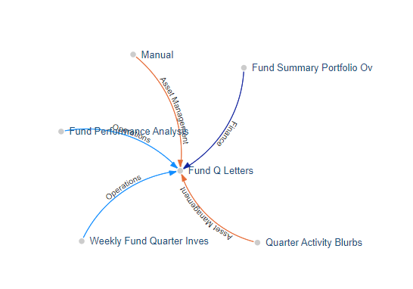
Network graph -Report/Deliverable with Data Sources and Data Source Owner
Similarly, the preparation of the Co-investor report is contingent on inputs from the Operations team, Asset Management and Investor Relations.
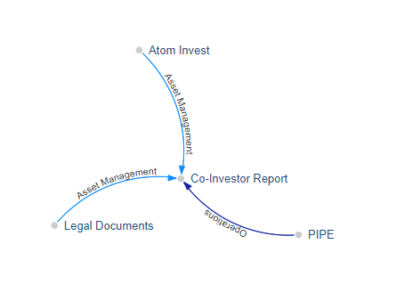
Network graph -Report/Deliverable with Data Sources and Data Source Owner

These interdependencies not only add layers of manual effort but also increase the risk of delays if one element in the chain is not delivered on time.
This interconnected workflow demonstrates the importance of creating more streamlined processes to reduce redundancy and dependency on individual contributors while addressing the inefficiencies caused by undocumented and decentralized inputs. Investing in automation, centralized data repositories, and standardized data integration processes could help alleviate these challenges. It would also ensure that deliverables are produced more consistently and within shorter timelines, regardless of resource availability or the need for ad hoc contributions from specialized teams.

Other options:
Overall:
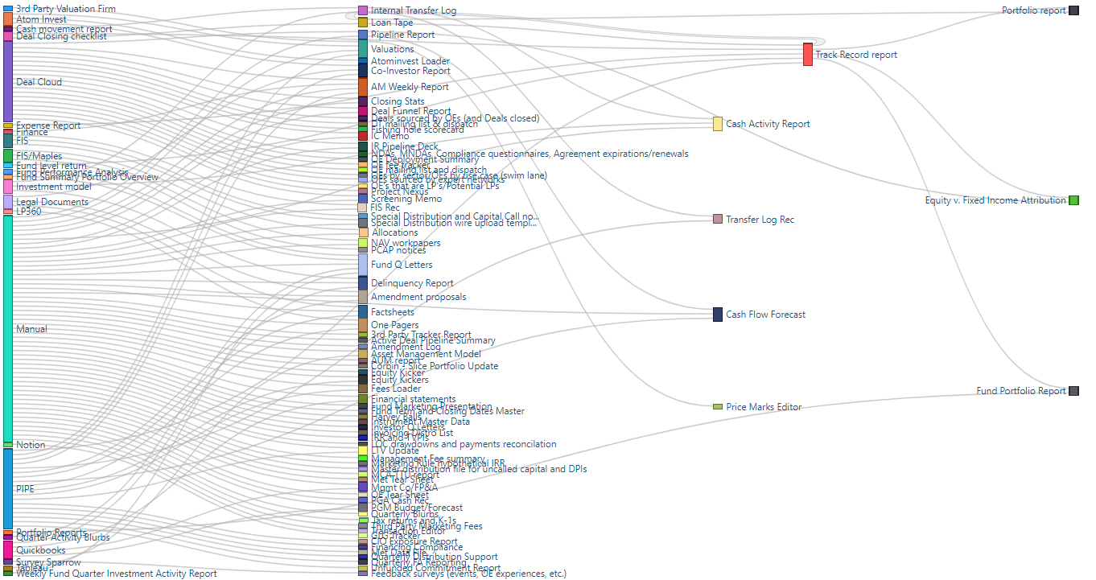
Fund Q Letter:
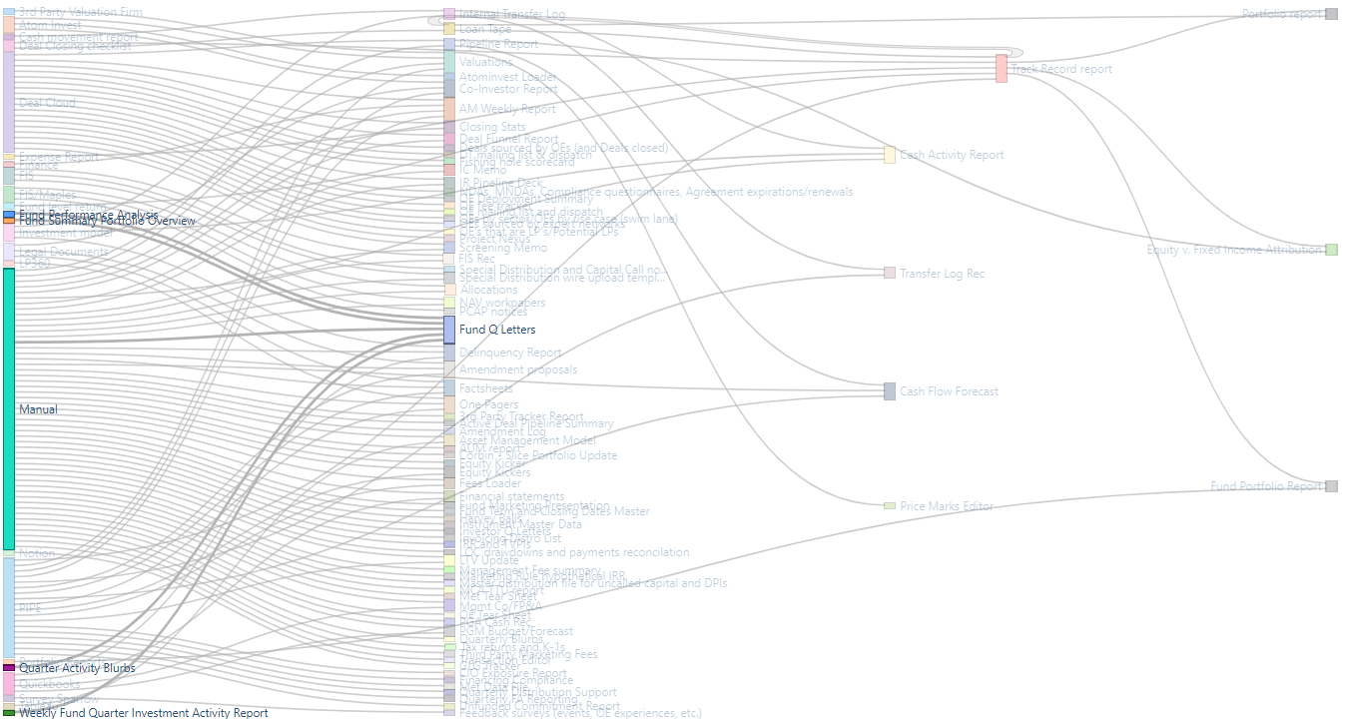
Co-Investor report:
